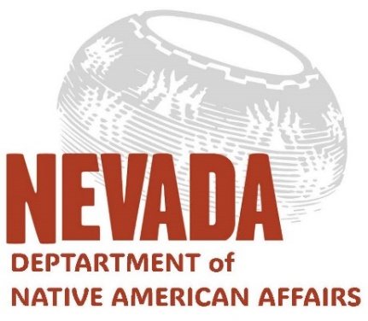 | NEVADA INDIAN COMMISSION  Joe Lombardo | Governor  Stacey Montooth | Executive Director | ADMINISTRATIVE OFFICES  5500 Snyder Avenue, Bldg. 3  Carson City, NV 89701 | MAILING ADDRESS  5366 Snyder Avenue  Carson City, NV 89701

Meeting Notice & Agenda
Indian Education Advisory Committee (IEAC)

December 10, 2024
3 pm
Indian Education Advisory Committee Topic: Indian Education Strategic Plan
ZOOM:
Join Zoom Meeting
https://us06web.zoom.us/j/81628458361?pwd=SDj9UrvxrZ3mnTn31U55b08KX39fYM.1
Meeting ID: 816 2845 8361
Passcode: 483223
---
One tap mobile
+17207072699,,81628458361#,,,,*483223# US (Denver)
+12532050468,,81628458361#,,,,*483223# US

AGENDA
- Agenda items may be taken out of order at the discretion of the Chair to accommodate people appearing before the Committee and/or to aid in the time efficiency of the meeting.

- Items may be removed from the agenda at any time. Also, items may be combined for consideration by the Committee.
- Public comments are welcomed by the Committee but will be limited to five minutes during the Public Comment agenda items.
- Public comment is for discussion only, and action may not be taken on any matter brought up under this agenda item until scheduled on an agenda for action at a later meeting, per NRS241.020.
- Action items are noted by the phrase “possible action” and typically include review, approval, denial and/or postponement of specific items. Certain items may be referred to a subcommittee for additional review and action.
- The public may acquire this agenda and supporting materials, pursuant to NRS 241.020 (2) by contacting the DNAA at 775-687-7605 or snez@nic.nv.gov .

“I would like to begin our Indian Education Advisory Committee meeting by acknowledging that we gather today from the ancestral homelands of the Pipa Aha Macav, Numa, the Newe, the Nuwuvi, and the Waší∙šiw who have lived in the Great Basin since time began. Please join me in expressing our deepest respect and gratitude to our five major Indigenous groups; the Mojave, the Northern Paiute, the Shoshone, the Southern Paiute, Washoe and Mojave--not just the original caretakers of the land we now call Nevada--but for their enduring stewardship and protection of our shared lands and waterways. Today, the IEAC reaffirms its commitment to improve the quality of life for our 28 Tribal Nations, Bands, Colonies, and the 62,000-plus Urban Indians who chose to make Nevada their current home.”

  - Roll Call - Establish Quorum

  - Invocation

  - Welcome and Introductions

  - Initial Public Comment

  - Approval of Minutes (Aug 7, Aug 8, Oct 28 & Nov 22) - Discussion and Possible Action

  - Strategic Plan - Discussion and Possible Action

  - Agenda Items for Future Meetings - Discussion and Possible Action

  - Set Next Meeting - Discussion and Possible Action
  - Final Public Comment

  - Adjournment

Notice of this meeting was posted in the following locations:
Notice Nevada.gov
Nevada’s Inter-Tribal Council of Nevada,
10 State Street, Reno, NV
Nevada Department of Education, 700 E. Fifth St., Suite 113, Carson City, NV
Nevada Department of Education, 2080 E. Flamingo Road #210 Las Vegas, NV

